Xf Registration

1. **Day 1**

* Outline of the project is DONE
* Mongoose express server all is WORKING
* Model , controller ,router for registration is DONE

Simple registration is DONE

* Things to be DONE Next
* username (inside the schema ) --- Automatically or default username if not mentioned (current day LINE-20) /registerModel.js
* time – default as Date.now() but we have to format it like this

25 Oct 2023 or 2023 October 25

Suggestion for YOU –

* Try to use some advanced way to do this and check out the docs and ChatGPT for help and don’t copy or exact manner to implement same thing
* Try New thing to add and EXPLORE

# Controller Update #Day1 (ONLY 2 )

* getRegistered – for register if you head over to <http://localhost:8090/api/v1/register> (postmanAPI) **[Working]**
* getAllRegistered – get all the registered user data in one go

<http://localhost:8090/api/v1> (on home page ‘/’ ) **[Working]**

when you add { result: newRegistee.length – it will count the element present in collection }

@1. Talk About Tech Stack We Use (tech/technology/application/tool)

* Express, MongodB Atlas, Mongoose , PostmanAPI
* **Update** (Things to be DONE Next )
* Username part is DONE
* Date is not WORKING – like 23 August 2023 (NOT DONE)

When we change the type from Date to string it working like 23456755(this format) not 23 Aug 2023

**2) Day 2**

**Things to be DONE Next -**

**Advanced MongoDB / Mongoose Implementation chaiye bas !!!!**

* **Geospatial Queries – staff (Read and Implement)**
* **Virtual properties –**
* **Add some Aggregation Pipeline**

**# DONE Today**

1. **Phone Number encryption using crypto-js and decryption**
2. **Add some more field in Schema**
3. **User Name Is WORKING**

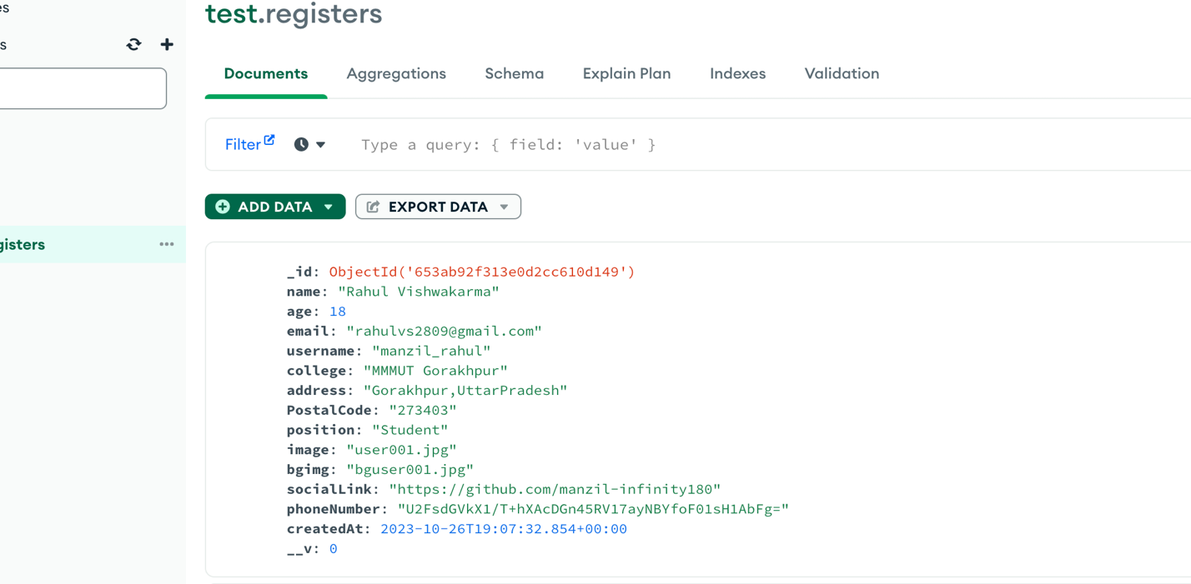

**What Next?**

It goes difficult on day 2 but we wrap up tomorrow most of thing

* Mongo revise
* We try to implement some cool api (query string feature)
* On Tag field we LOOK more (next day)

**@TechStack** – Mongodb and Js (TODAY)

**Thought / Conclusion**

* I am trying to focus on ADVANCED PART OF MONGOOSE
* But lagging with it – Will try tomorrow to Implement one of the advanced feature ( aggregation pipeline , geospatial,virtual , indexes )
* And focusing on user authentication (and try to implement the schema Based on OAuth data )